Telecom Quiz/Tutor Bot Report

  - Course Name: Data Analytics

Institution Name: Medicaps University – Datagami Skill Based Course

Student Name(s) & Enrolment Number(s):
Sr no | Student Name | Enrolment Number
1 | Isha Joshi | EN22CS301438
2 | Harsh Chouhan | EN22CS301387
3 | Goutam Choudhary | EN22CS301370
4 | Goutam Sharma | EN22CS301374
5 | Harshita Chouhan | EN22CS301406

Group Name: 03D4
Project Number: GAI-39
Industry Mentor Name:
University Mentor Name:
Academic Year:2026

Problem Statement & Objectives

Problem Statement
Telecom users often struggle to choose the most suitable mobile recharge plan due to the wide variety of options available across providers. Plans differ in price, data limits, validity, and additional benefits. Users must manually compare multiple plans, which is time-consuming and confusing.
There is a need for an intelligent, user-friendly system that:
- Displays telecom plans clearly
- Allows filtering based on budget and provider
- Visualizes price vs data comparison
- Provides smart interaction via chatbot interface

Project Objectives
The main objectives of the Telecom Bot project are:
- To develop an interactive web-based telecom plan dashboard.
- To allow users to filter plans based on budget and provider.
- To visualize telecom plan comparisons using graphical representations.
- To create a chatbot-style interface for user queries.
- To design a clean and professional UI using Streamlit.

Scope of the Project
The scope of the project includes:
- Displaying telecom recharge plans.
- Filtering plans dynamically.
- Visualizing relationships between price and data.
- Creating a chatbot input interface.
- Building an interactive analytics dashboard.

The project focuses on:
- User experience
- Data visualization
- Interactive filtering
- Clean UI design
The system currently works with structured telecom data and can be extended to real-time APIs in the future.

Proposed Solution

2.1 Key features
- Hero Section (Professional UI Header)
- Budget Slider Filter
- Provider Selection Filter
- Dynamic Plan Filtering
- Interactive Data Table
- Price vs Data Visualization Graph
- Chat-style User Query Interface
- Clean UI with subtle dividers
- Responsive layout using wide format

  - Overall Architecture / Workflow
Step 1: Data Initialization
Telecom plan data is stored in a structured format using a Pandas DataFrame.
Step 2: User Interaction
Users can:
- Enter queries in chatbot input
- Adjust budget slider
- Select provider
Step 3: Data Filtering Logic
Based on user input:
- Plans are filtered using budget

- Provider filter is applied
- Filtered dataset is generated
Step 4: Visualization
Filtered data is:
- Displayed in a dynamic dataframe
- Plotted using matplotlib scatter chart
Step 5: Output Display
Updated results are shown instantly in the UI.

  - Tools & Technologies Used

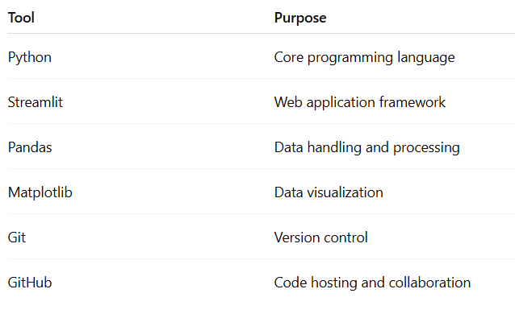

Results & Output

  - outputs
The application provides:
- A professional landing hero section.
- Interactive filters for telecom plans.
- Dynamic telecom plan table.
- Real-time updated scatter plot (Price vs Data).
- Chat interface for plan-related queries.

  - Reports / dashboards / models

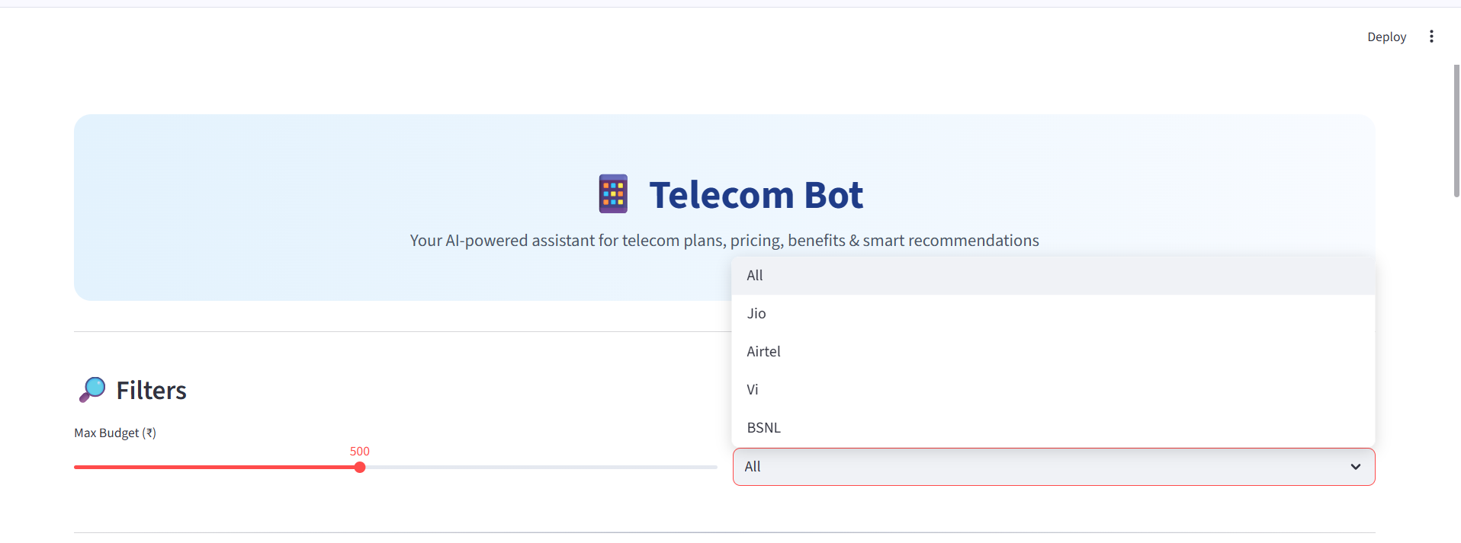
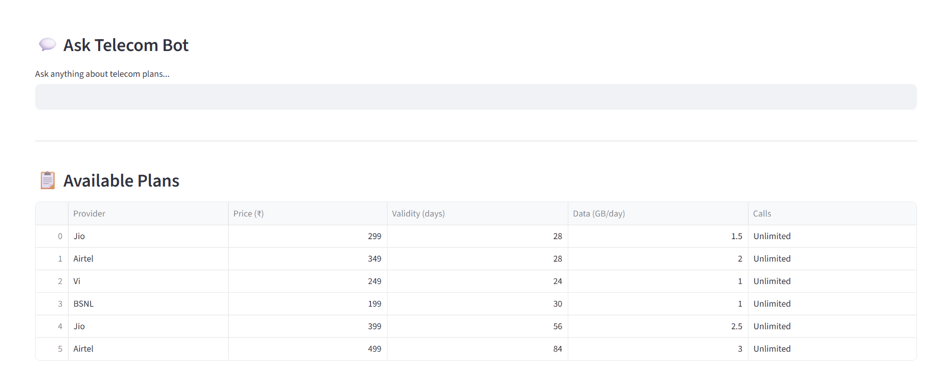
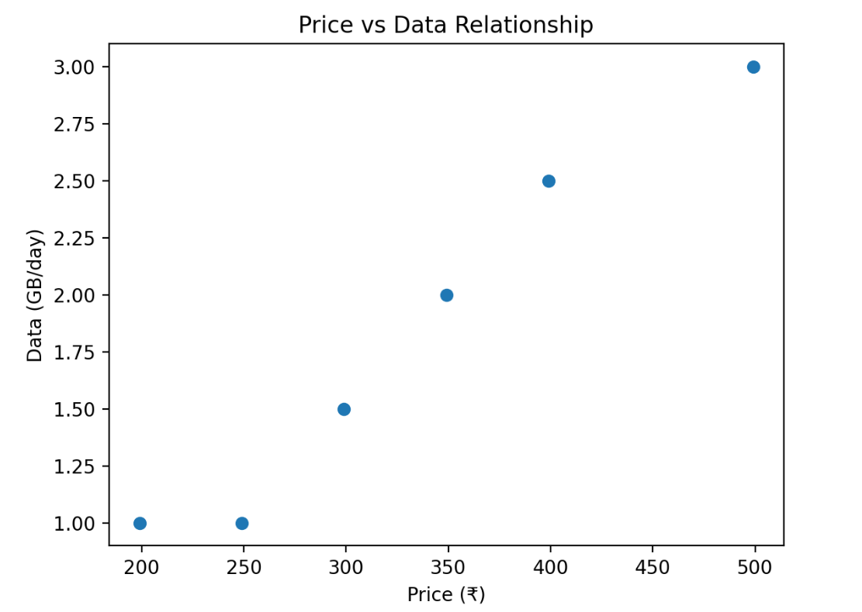

  - Key outcomes

- Successfully built a responsive Streamlit dashboard.
- Implemented dynamic filtering logic.
- Created interactive data visualization.
- Designed professional UI with custom CSS.
- Integrated user-friendly layout structure.

Conclusion
The Telecom Bot project successfully demonstrates the development of an interactive telecom plan analytics system using Python and Streamlit.
The project helped in:
- Understanding real-time filtering logic
- Implementing data visualization techniques
- Designing user-friendly dashboards

- Structuring a full-stack mini data analytics application
This project enhanced knowledge in:
- Python programming
- Data analytics
- UI design
- Streamlit framework
- Git version control

Future Scope & Enhancements
The project can be further enhanced by:
- Integrating real telecom APIs.
- Adding AI-powered plan recommendation engine.
- Deploying the application on Streamlit Cloud.
- Adding user login and personalization.
- Creating advanced analytics dashboards.
- Adding bar charts, heatmaps, and trend analysis.
- Implementing database integration (MySQL / MongoDB).
- Making it mobile-responsive for production use.

